ITA0609 - Machine Learning
CO4 AT1
Name : Vishwa V
Reg No : 192421374

1.

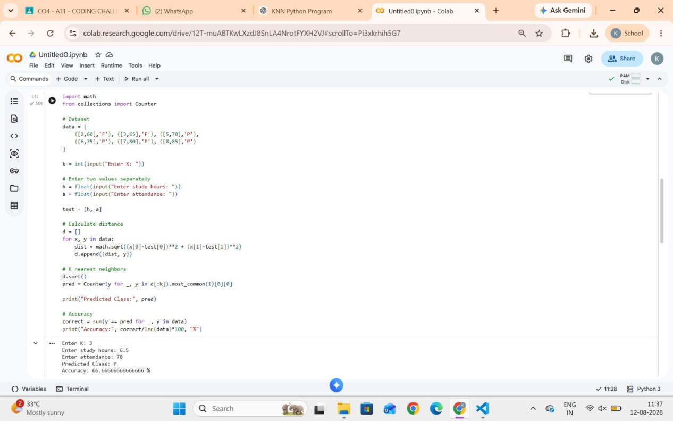

2.

